
CASA OF ARIZONA
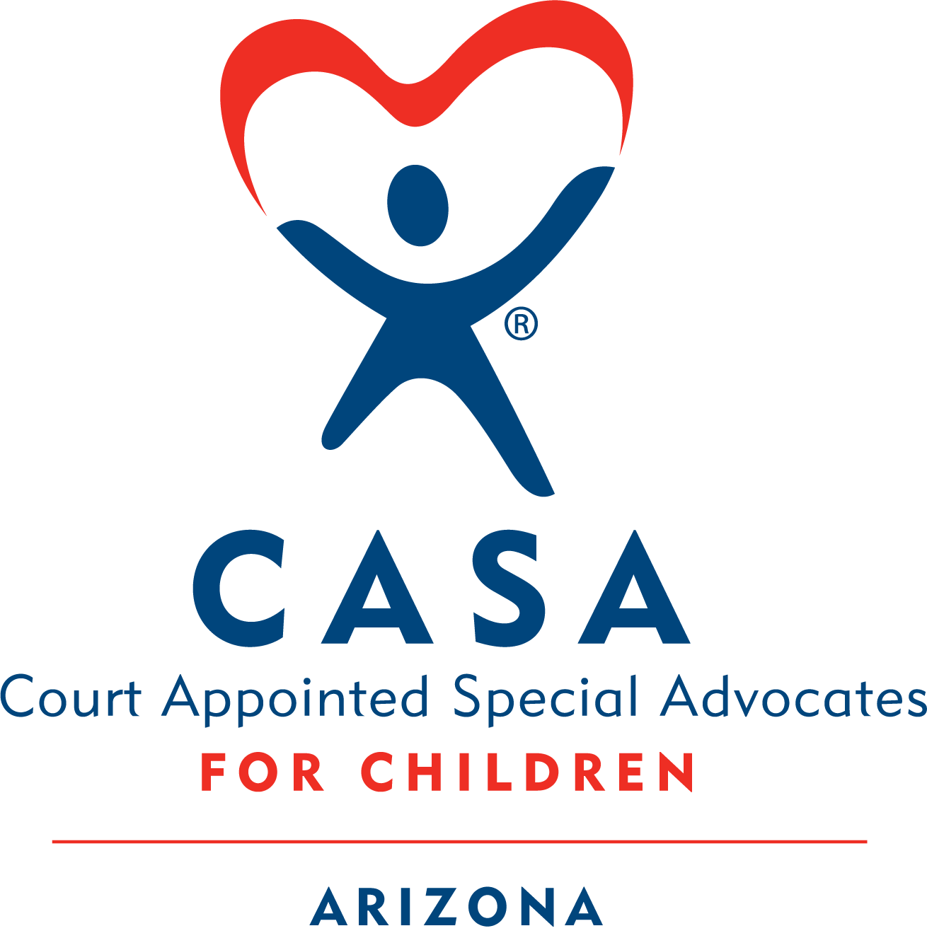

Module 4 Homework
Contents
❖ Activity 4.1 Understanding Substance Use 2
❖ Activity 4.2 What Challenges You? 5
❖ Activity 4.3 Stages of Change 6
❖ Activity 4.4 Stigma 7
❖ Activity 4.5 What is Culture? 7
❖ Activity 4.6 Stereotyping vs Cultural Awareness, Responsiveness & Humility 8
❖ Activity 4.7 Tips for Becoming More Culturally Aware, Responsive & Humble 11
❖ Activity 4.8 Advocating for LGBTQ+ Youth 12
❖ Activity 4.10 Rosa Case 14

Activity 4.1 Understanding Substance Use

Definitions
According to the American Society of Addiction Medicine (n.d):
addiction is a treatable, chronic medical disease involving complex interactions among brain circuits, genetics, the environment, and an individual’s life experiences. People with addiction use substances or engage in behaviors that become compulsive and often continue despite harmful consequences.
Prevention efforts and treatment approaches for addiction are generally as successful as those for other chronic diseases (para 1 & 2).
Addiction, also called substance use disorder involves the following:
• Persistent pattern of repeated substance use resulting in a strong internal drive to continue use
• Development of increasing tolerance to the substance
• Withdrawal symptoms when the drug use is reduced or stopped
• Continued use despite significant substance related problems
(APA, 2023, para 1)

Causes
There are different theories about how substance use disorders start and what causes them. According to the American Society of Addiction Medicine, substance-related disorders are biopsychosocial, meaning they are caused by a combination of biological, psychological, and social factors.
It is important to remember that people suffering from substance use disorders are not choosing to be in the situation they are in. Try to see those who are impacted by addiction as separate from their disease. In other words, they should be seen as “sick and trying to get well,” not as “bad people who need to improve themselves.” This will help you remember to be compassionate and nonjudgmental in your approach.

Treatment
The field of addiction treatment recognizes an individual’s entire life situation. Treatment should be tailored to the needs of the individual and guided by an individualized treatment plan based on a comprehensive assessment of the affected person, as well as their family. Treatment can include a range of services depending on the severity of the addiction, from a basic referral to 12-step programs to outpatient counseling, intensive outpatient/day-treatment programs, and inpatient/residential programs.
Treatment programs use several methods, including assessment; individual, group and family counseling; educational sessions; aftercare/continuing-care services; and referral to 12-step or Recovery support groups, and medically assisted treatment. Recovery is a process—and relapse is part of the process.
It may be helpful to define relapse vs. lapse so we have the right language to
address what is occurring. A lapse is when an individual returns to using substances, then quickly discontinues. An example could be an individual who has been triggered and turns to substance use to cope, then quickly gets back on track implementing the skills they learned through their recovery process. A
relapse is when an individual returns to using substances at the same frequency and usage as they had prior to treatment.

Prevalence
“Parental addiction is a significant factor in child abuse and neglect cases, with studies suggesting 60% to 80% of families in the child welfare system are affected by addiction (National Center on Substance Abuse and Child Welfare, 2023).”
It is helpful to remember that children of parents living with substance use issues still love their parents, even though the parents may have abused or neglected them.

The 2022 National Survey on Drug Use and Health (NSDUH) used multimode data collection, in which respondents completed the survey in person or via the web. Estimates based on multimode data collection in 2022 are not comparable with estimates from the 2020 NSDUH or prior years. Although most estimates can be compared between 2021 and 2022, highlights are presented for the 2022 NSDUH only.

Substance Use Disorders

• In 2022, 48.7 million people aged 12 or older (or 17.3%) had a substance use disorder (SUD) in the past year, including 29.5 million who had an alcohol use disorder (AUD), 27.2 million who had a drug use disorder (DUD), and 8.0 million people who had both an AUD and a DUD.
• In 2022, the percentage of people aged 12 or older with an SUD in the past year was highest among young adults aged 18 to 25 (27.8% or 9.7 million people), followed by adults aged 26 or older (16.6% or 36.8 million people), then by adolescents aged 12 to 17 (8.7% or 2.2 million people)
• Among the 29.5 million people aged 12 or older in 2022 with a past year AUD, most (59.1%) had a mild disorder compared with about 1 in 5 (20.7%) who had a severe disorder.
• Among the 19.0 million people aged 12 or older in 2022 with a past year marijuana use disorder, most (55.1%) had a mild disorder compared with only 17.3% who had a severe disorder.

Harm Reduction
Definition: “Harm reduction incorporates a spectrum of strategies that includes safer use, managed use, abstinence, meeting people who use drugs where they’re at, and addressing conditions of use along with the use itself" (National Harm Reduction Coalition).
Principles of Harm Reduction:
- Accepts, for better or worse, that licit and illicit drug use is part of our world and chooses to work to minimize its harmful effects rather than simply ignore or condemn them
- Understands drug use as a complex, multi-faceted phenomenon that encompasses a continuum of behaviors from severe use to total abstinence, and acknowledges that some ways of using drugs are clearly safer than others
- Establishes quality of individual and community life and well-being — not necessarily cessation of all drug use — as the criteria for successful interventions and policies
- Calls for the non-judgemental, non-coercive provision of services and resources to people who use drugs and the communities in which they live in order to assist them in reducing attendant harm
- Ensures that people who use drugs and those with a history of drug use routinely have a real voice in the creation of programs and policies designed to serve them
- Affirms people who use drugs (PWUD) themselves as the primary agents of reducing the harms of their drug use and seeks to empower PWUD to share information and support each other in strategies which meet their actual conditions of use.
- Recognizes that the realities of poverty, class, racism, social isolation, past trauma, sex-based discrimination, and other social inequalities affect both people’s vulnerability to and capacity for effectively dealing with drug-related harm
- Does not attempt to minimize or ignore the real and tragic harm and danger that can be associated with illicit drug use

Activity 4.2 What Challenges You?

It is important to remember, in Dependency cases, when a parent is involved with drugs or alcohol, the criteria for safety relates to the parent’s ability to parent effectively, not the fact that they are using substances. For example:
- A parent may be emotionally and physically unavailable to the child.
- A parent’s mental functioning, judgment, inhibitions and/or protective capacity may be seriously impaired by alcohol or drug use, placing the child at increased risk of all forms of abuse and neglect, including sexual abuse.
- A parent who uses substances may “disappear” for hours or days, leaving the child alone or with someone unable to meet the child’s basic needs.
- A parent may also spend the family’s income on alcohol and/or other drugs, then be unable to provide the child of adequate food, clothing, housing, and healthcare.
  - The resulting lack of resources often leads to unstable housing, which results in frequent school changes, loss of friends and belongings and an inability to maintain important support systems (religious communities, sports teams, neighbors).
- A child’s health and safety may be seriously jeopardized by criminal activity associated with the use, manufacture, and distribution of illicit drugs in the home.
- Sometimes, a parent’s substance abuse may lead to criminal behavior and periods of incarceration, depriving the child of parental care.
- Prenatal exposure to alcohol or other drugs may impact a child’s development.

Activity 4.3 Stages of Change

Please view the image and read the material below on the stages of change.

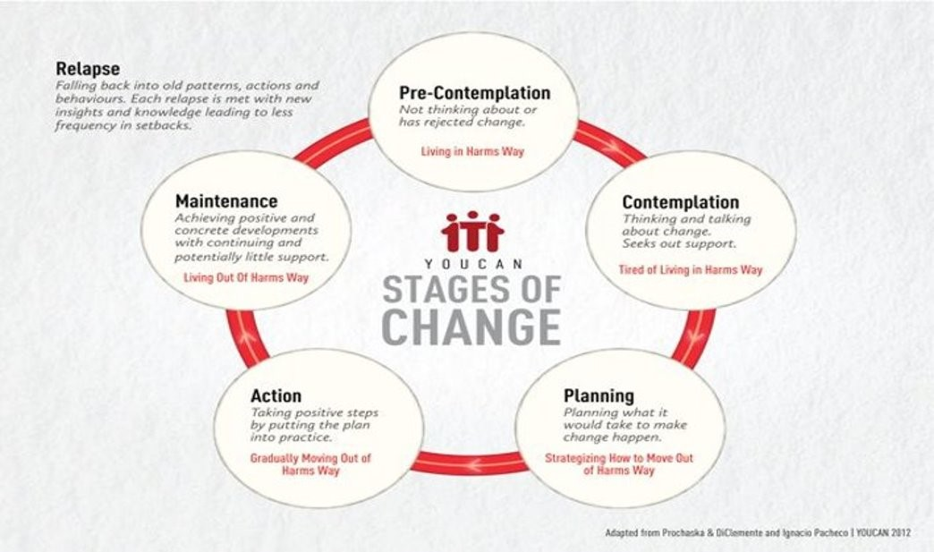
The stages of change recognize that change is difficult. It is not easy to get from first recognizing that there is a problem to the point of maintaining behavior change. The stages of change also recognize that the motivation to change is not stagnate and that the journey of behavior change is often not linear.
As people consider making a change in their life, they may spend more time in earlier stages of changes requiring patience from those that support them. Often when making a difficult behavior change like taking action to address substance use disorder people may find themselves experiencing lapses/relapses. When experiencing a relapse, the individual may find themselves back at an earlier stage of change like contemplation and require the provider to match their stage of change and help resolve their ambivalence about changing their behavior. The motivation to change is intrinsic and the provider can help move the individual closer to activating the changes they want to make in their own lives.

Activity 4.4 Stigma

Part 1: Read the following attachment regarding stigma.

Part 2: Read the document Birth Parents with Trauma Histories in the Child Welfare System – A Guide for Court-Based Child Advocates below.

Activity 4.5 What is Culture?
- Culture is a learned pattern of customs, beliefs, and behaviors, socially acquired and socially transmitted through symbols and widely shared meanings. Culture can be defined as an organized group of learned responses and ready-made solutions to problems people face and how to live day-to-day.
- Culture is not only bound by race and ethnicity. Groups of people who work in certain fields may develop a unique culture. They have a unique language, practice model, etc. Culture defines how we do things, think about things and talk about things.

Activity 4.6 Stereotyping vs Cultural Awareness, Responsiveness & Humility

Stereotypes can impact how a volunteer approaches and builds relationships with families and children. Stereotypes are rigid and inﬂexible. Stereotypes hold even when a person is presented with evidence contrary to the stereotype. Stereotypes are harmful because they limit people’s potential, perpetuate myths and are gross generalizations about a particular group. Even stereotypes that include “positive” elements (e.g., “they” are quite industrious) can be harmful because the stereotypes are rigid, limiting and generalized.
Unlike stereotyping, cultural humility "challenges us to learn from the people with whom we interact, reserve judgment, and bridge the cultural divide between our perspectives in order to facilitate well-being and promote improved quality of life" (Spotted Elk, 2024).
As an advocate, it is important to practice self-reflection in order to examine your biases and recognize that they are based on your own life and do not reﬂect what is true for the stereotyped groups. Everyone has certain biases. Everyone stereotypes from time to time. Developing cultural humility is an ongoing process of recognizing and overcoming these biases by thinking ﬂexibly and practicing a beginner’s mind. This means knowing that we don't know it all and being open to a process of continuously learning from the individuals and families.
It is important to recognize that child-rearing practices vary across cultures. For instance, the following mainstream US child-rearing practices may be viewed as harmful to children by people from other countries: isolating children in beds or rooms of their own at night, making children wait for food when they are hungry, requiring children to wear painful braces on their teeth, and forcing young children to sit in a classroom all day.
Conversely, practices that are culturally acceptable elsewhere may be misunderstood in the United States. One example is the Southeast Asian practice of “coin rubbing,” a traditional curing method in which heated metal coins are pressed on a child’s body. This practice is believed to reduce fevers, chills, and headaches. Because it generally leaves red streaks or bruises, it can easily be misdiagnosed as child abuse by those who don’t understand the intention behind this cultural practice.
Practicing cultural awareness and responsiveness in child advocacy means being respectful of the cultural norms, values, traditions, and parenting styles of those with whom you work. Striving to be culturally humble means cultivating an open mind and new skills and meeting people where they are, rather than making them conform to your standards. Each child and each family is made up of a combination of cultural, familial and personal traits. In working with families, you need to learn about an individual’s or family’s culture. Practice respectful curiosity and ask the people you are working with about their cultural needs. It might feel awkward at ﬁrst, but learning how to ask questions respectfully is a vital skill to develop. Once people understand that you sincerely want to learn and be respectful, they are usually forthcoming.
10 Beneﬁts of Practicing Cultural Humility in Child Advocacy
1. Ensures that case issues are viewed from the cultural perspective of the child and/or family:
• Considers cultural norms, practices, traditions, intra-familial relationships, roles, kinship ties and other culturally appropriate values
• Advocates for demonstrated sensitivity to this cultural perspective on the part of caseworkers, service providers, caregivers or others involved with the child and family
2. Ensures that the child’s long-term needs are viewed from a culturally appropriate perspective
• Considers the child’s need to develop and maintain a positive self-image and cultural heritage
• Considers the child’s need to positively identify and interact with others from their cultural background
3. Prevents cultural practices from being mistaken for child maltreatment or family dysfunction
4. Assists with identifying when parents are truly not complying with a court order and when the problem is culturally inappropriate or a result of non-inclusive service delivery
5. Contributes to more accurate assessment of the child’s welfare, family system, available support systems, placement needs, service needs and delivery
6. Decreases cross-cultural communication clashes and opportunities for misunderstandings
7. Allows the family to utilize culturally appropriate solutions for problem solving
8. Encourages participation of family members in seeking assistance or support
9. Recognizes, appreciates and incorporates cultural differences in ways that promote cooperation
10. Allows all participants to be heard objectively
Adapted from a document created by CASA for Children, Inc., Portland, Oregon.
Institutional Bias Checklist for Volunteers
As a CASA volunteer, ask yourself:
• What assumptions have I made about the cultural identity, genders and background of this family?
• What is my understanding of this family’s unique culture and circumstances?
• How are my recommendations speciﬁc to this child and this family?
• What evidence has supported the conclusions I have drawn and how have I challenged unsupported assumptions?
• Have reasonable efforts (or active efforts in ICWA cases) been made in an individualized way to match the needs of the family?
• Have relatives been fully explored as preferred placement options as long as they can protect the child and support the permanency plan?
• Are there family members and/or other important people who have not been contacted who should be involved in this process?
• What services are being offered to allow the child to remain at home or reunify the family (as applicable)? Are these services culturally appropriate? How are these services related to the safety threat?
• Are this child and family receiving the same level and tailoring of services as other children and families?

Activity 4.7 Tips for Becoming More Culturally Aware, Responsive & Humble

• Learn about your culture and values, focusing on how they inform your attitudes, behavior and verbal and nonverbal communication.
• Don’t think that “good” and “right” values exist in your own culture exclusively; acknowledge that the beliefs and practices of other cultures are just as valid.
• Question your cultural assumptions: Check their reality, rather than immediately acting on them.
• Accept cultures different from your own and learn by sharing in individuals and families perspectives.
• Examine the circle in which you live, work, and play (this reﬂects your choice of peers). Expand your circle to include people of other races, cultures, values, and beliefs.
• Learn more about the history of racism and oppression in the United States.
- Continue to practice respectful curiosity and ask about cultural needs.

- Follow appropriate protocol: Know and demonstrate respectful behavior based on the values of the individuals and families.

- Use collaborative networks—churches, synagogues, mosques and other spiritual groups, community organizations or other natural support groups of that culture.
• Understand that any change or new learning experience can be challenging, unsettling and tiresome; give yourself a break and allow for mistakes. Also apologize when needed.
- Remember the reciprocal nature of relationships—give something back.

- See practicing cultural humility as a lifelong journey of learning.

- Be courageous enough to address biased thinking when you hear it in others.
Adapted from materials developed by CASA for Children, Inc., Portland, Oregon.

Activity 4.8 Advocating for LGBTQ+ Youth

There is a disproportionate number of LGBTQ+ youth in foster care. At home, LGBTQ+ youth are more likely than their non-LGBTQ peers to face disapproval, abuse and neglect. Family conflict often becomes so intense that the youth are forced to leave home. Once in the child welfare system, many LGBTQ+ youth continue to be misunderstood, facing abuse, harassment, and isolation. In foster homes and group care facilities, LGBTQ youth are often mistreated and even harmed by staff, caregivers and other young people. They also have more frequent placement disruptions and are more likely to be placed in congregate care settings (as opposed to relative placements or licensed foster homes).
Surveys of young people between the ages of 12-21 in foster care indicate 30% to 34% of the population identifies as LGBTQ+. Research has also shown that this population is at increased risk of suicide, depression, increased anxiety, and other negative mental health outcomes. For example, the Trevor Project has found that more than half of transgender and nonbinary youth have considered suicide (Trevor Project, 2022). Access to affirming spaces, materials, and care reduces this risk greatly.
Pronouns 101
What is a pronoun?
A pronoun is a word used to refer to either the people who are talking (like “I” or “you”) or a person being talked about in the third person (like “she/her,” “he/him,” and “they/them”). Since some pronouns are gendered (“she/her” and “he/him”), it is important to be intentional about the way we use pronouns as we all work to create as inclusive an environment as possible.
Why do pronouns matter?
Ask yourself how many times someone has used your name or a pronoun to refer to you today. Chances are this has happened countless times. Now, imagine that your coworker, or a family member, or your doctor or a friend routinely calls you by the wrong pronoun. That would be hard. This is why using a person’s chosen name and pronouns is essential to affirming their identity and showing basic respect. The experience of being misgendered – having someone use the incorrect pronouns to refer to you – can be uncomfortable and hurtful. The experience of accidentally misgendering someone can be difficult for both parties. Routinely asking and providing pronouns helps everyone avoid assumptions and feel comfortable interacting.

What a CASA Can Do
- Create opportunities for people to share their pronouns with you rather than assuming you know their pronouns based on their appearance. For example, when introducing yourself share your pronouns like this:
  - In one-on-one conversation: “Hi, I’m John and I go by he/him. Nice to meet you.”
  - In a meeting: “Hi everyone. I’m Mollie. I’m the senior program manager and I go by she/her.”
  - In your e-mail signature next to your name: E. Wilson (pronouns: they/them/theirs)
- If you don’t know someone’s pronouns, it’s okay to ask. You can say, “What pronouns do you use?” or “What pronouns do you go by?” or “What pronouns would you like me to use when I refer to you?”
- Always use someone’s chosen (preferred) pronouns unless you’ve been asked not to do so for a specific reason (e.g., safety or privacy concerns).
- Practice! Practice! Practice! It takes intention to consistently use someone’s correct pronouns if you previously used different pronouns for that person or if you’re using pronouns that are new to you. Take the time to practice referring to the person with the correct pronouns in conversation and in written communication. (Tip: Worried about misgendering someone in an email? Do a quick “CTRL+F” and search for any use of an incorrect pronoun before hitting send.)
- If you make a mistake, apologize and move on. Help others by gently correcting them if they misgender someone.

Activity 4.10 Rosa Case

Click the pdf below to read the latest documents for the Rosa Case which includes DCS Progress Report to the court in advance of the next Review Hearing and a Minute Entry dismissing the case as to Israel.
Our updated timeline at this stage is removal of the children in Jan 2024, initial hearings in Jan 2024, first review hearing in June 2024, next review hearing is scheduled for September 2024.
As you read the case information, it will be helpful for you to take notes on the pertinent information as you will be asked to complete a group activity in class where you consider what information will go into the assessment section of your court report (the CASA court report is in advance of the Sept 2024 review hearing). In later sessions, you will discuss your opinions and concerns to come up with recommendations with your group. So, please keep those activities in mind as you read and take notes that will help you in class.

Citations
American Psychological Association. (Updated 2023, November 15). Substance dependence. In APA Dictionary of Psychology. APA Dictionary of Psychology
American Society of Addiciton Medicine. (n.d.). Definition of addiction. What is the Definition of Addiction?
National Center on Substance Abuse and Child Welfare. (2023, October 26). How to Use Data for Change: Improving Outcomes for Families Affected by Substance Use. How to Use Data for Change: Improving Outcomes for Families Affected by Substance Use - AD - YouTube
National Institue on Drug Abuse. (2023, November 17). Your Words Matter-Language Showing Compassion and Care for Women, Infants, Families, and Communities Impacted by Substance use Disorder. Your Words Matter – Language Showing Compassion and Care for Women, Infants, Families, and Communities Impacted by Substance Use Disorder | National Institute on Drug Abuse (NIDA)
Substance Abuse and Mental Health Services Administration. (2022). 2022 National Survey on Drug Use and Health (NSDUH) Annual National Report. 2022 NSDUH Annual National Report | CBHSQ Data
All Children All Families, Human Rights Campaign. Microsoft Word - HRC ACAF Pronouns 101

